Name: PRATIK SUNIL ABHANG
Registration ID: 260640160209
Question
Q1.
Your current directory is:
/home/student/Documents/Linux
Navigate to the Downloads directory using only a relative path.

Command
cd ../../Downloads

Output
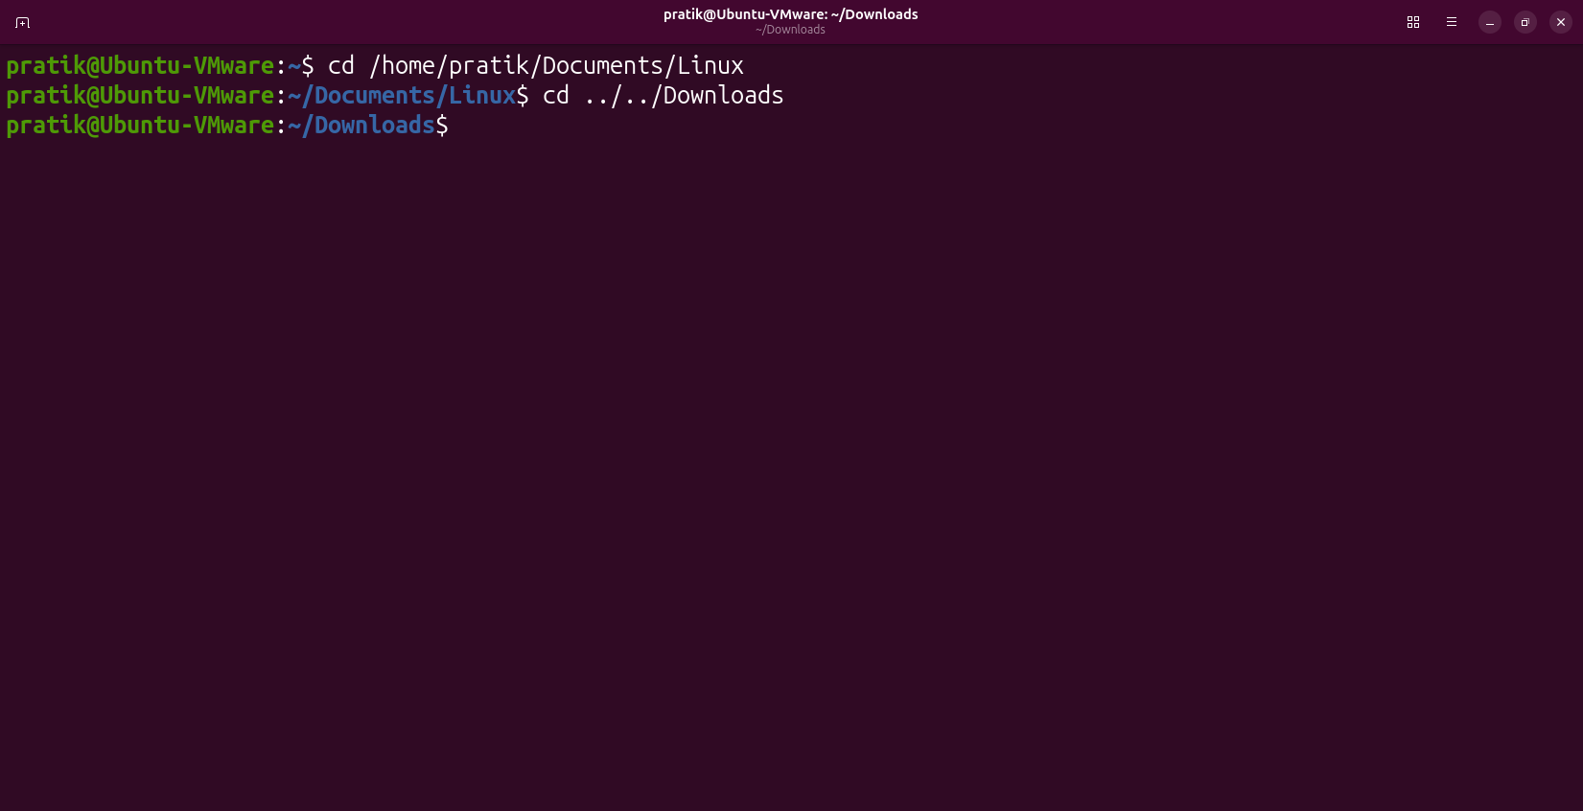

Question
Q2.
Without changing your current directory, display the contents of:
/var/log

Command
ls /var/log

Output
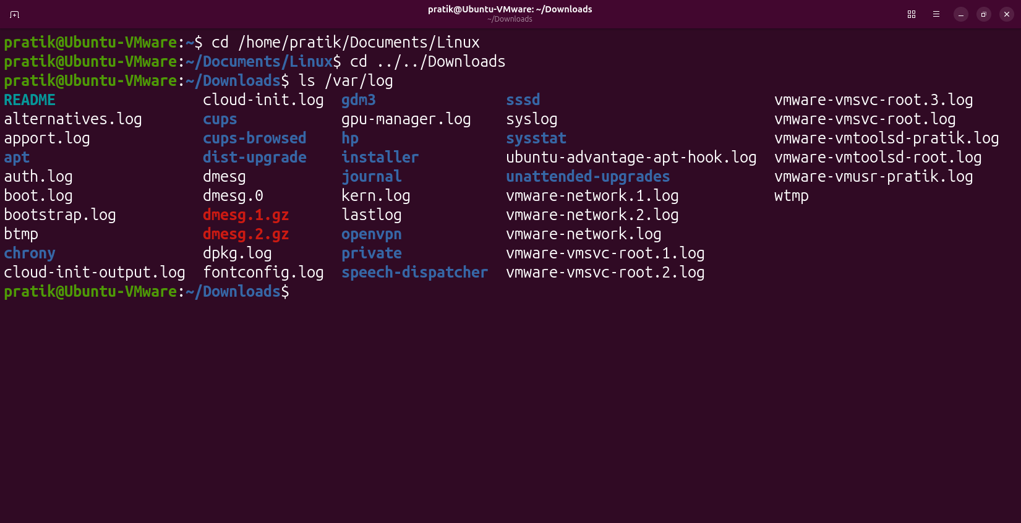

Question
Q3.
You are in:
/home/student/Documents/Projects
Go to your home directory without typing its full path.

Command
cd ~

Output
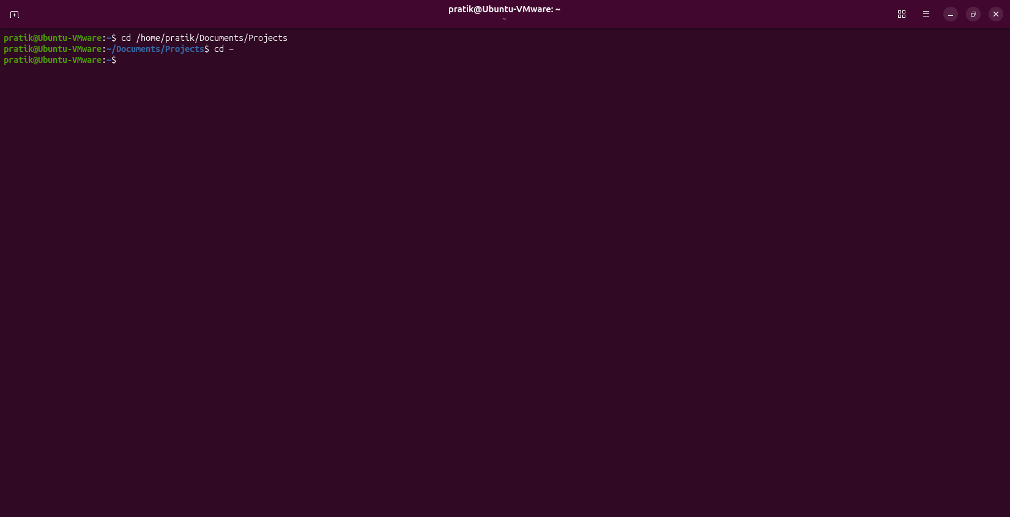

Question
Q4.
You are inside:
/home/student/Documents/Linux/Scripts
Navigate to:
/home/student/Documents
using only a relative path.

Command
cd ../..

Output
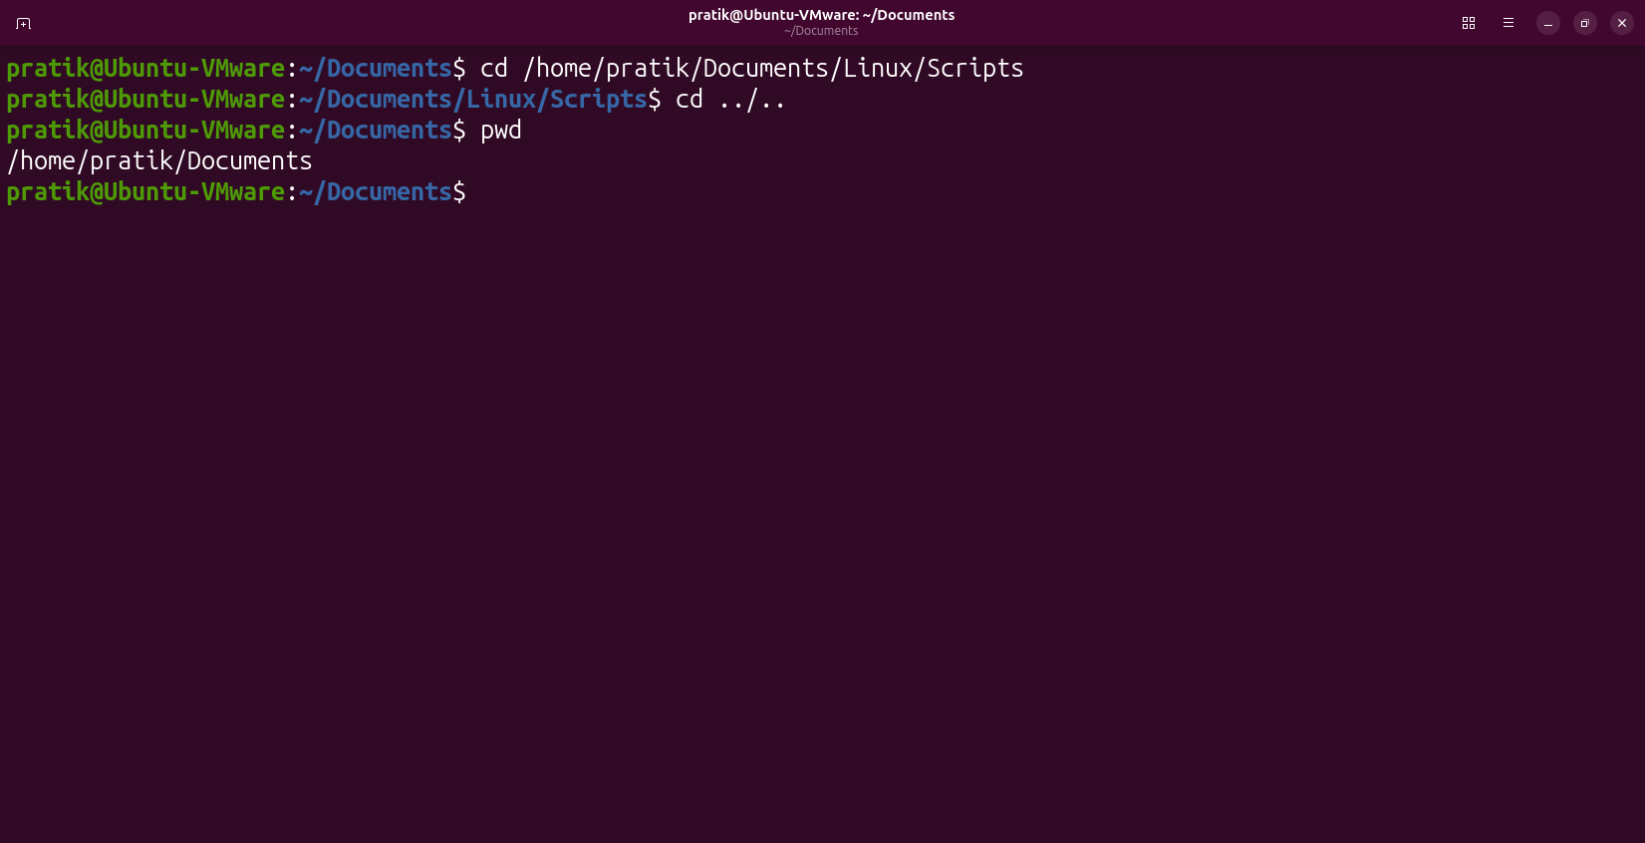

Question
Q5.
Which command will display your current location after changing directories?

Command
pwd

Output
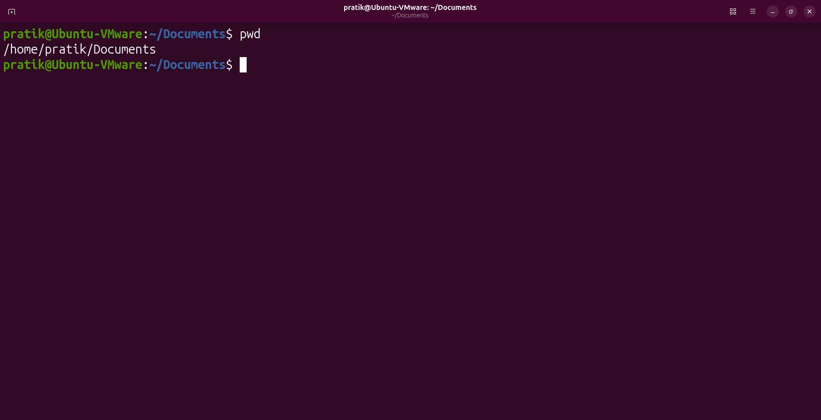

Question
Q6.
Display all files, including hidden files, in long listing format.

Command
ls -la

Output
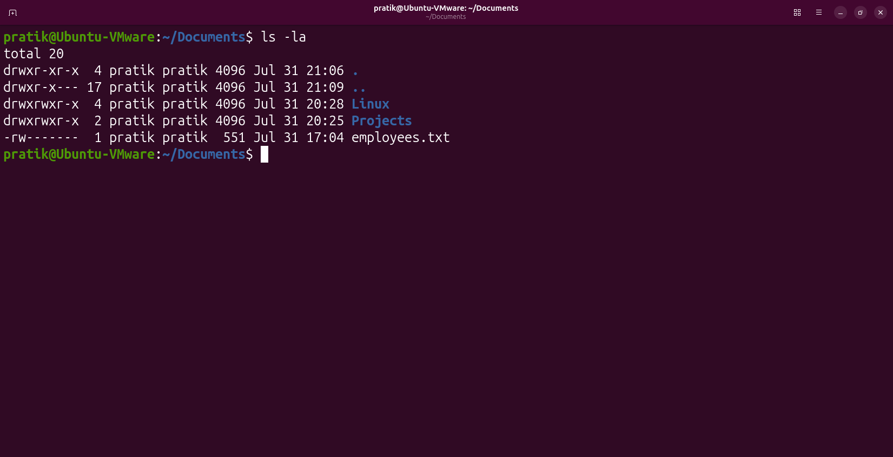

Question
Q7.
List only the contents of the /etc directory without entering it.

Command
ls /etc

Output
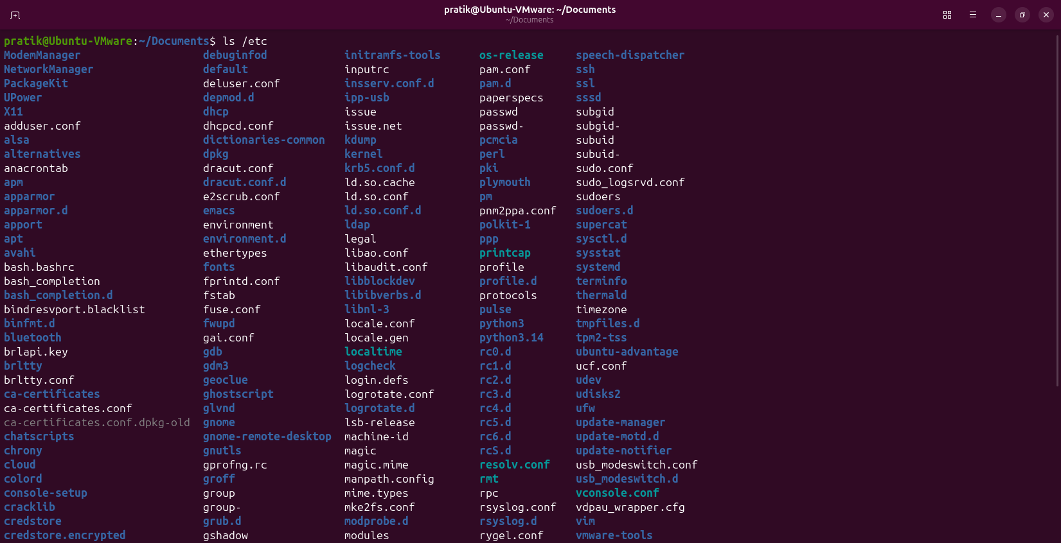

Question
Q8.
Display files sorted by newest first.

Command
ls -lt

Output
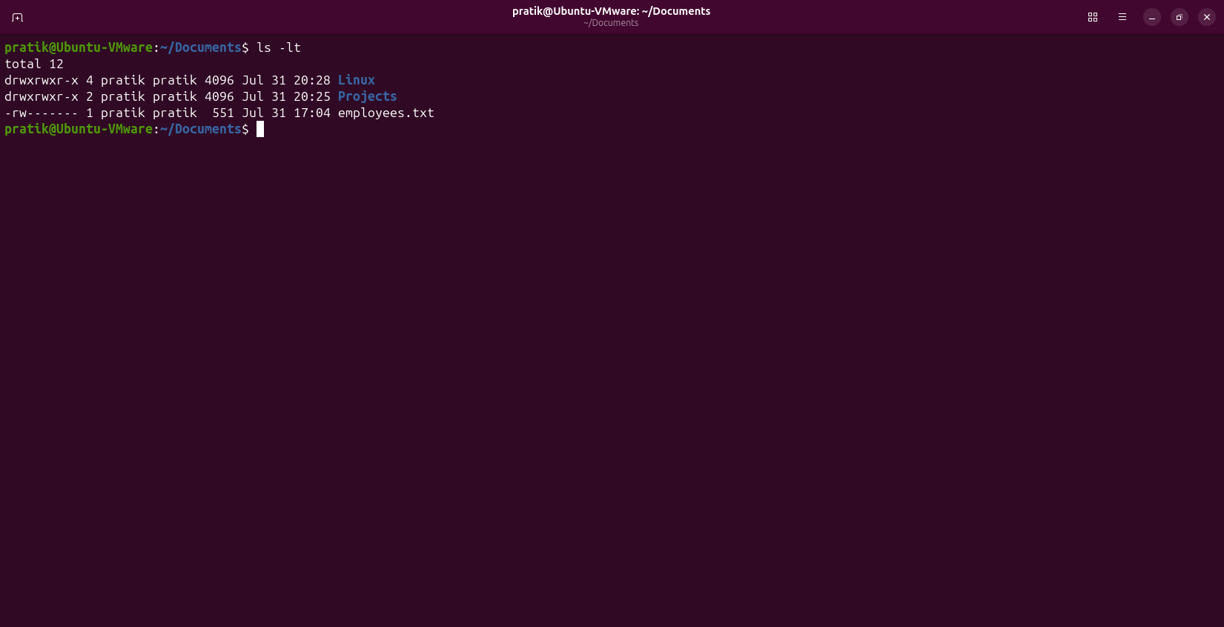

Question
Q9.
Which command shows human-readable file sizes?

Command
ls -lh

Output
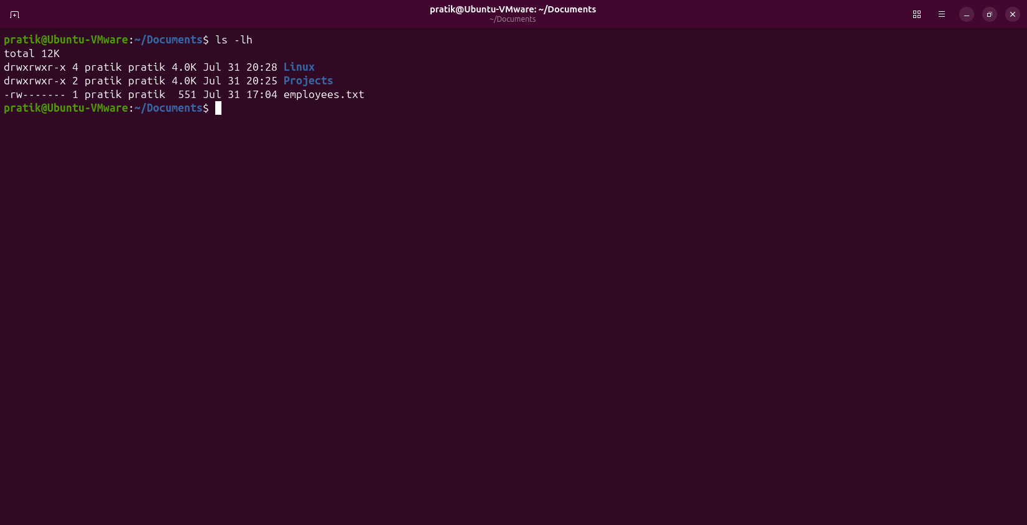

Question
Q10.
You are inside /home/student.
Display the contents of Documents/Linux using a relative path.

Command
ls Documents/Linux

Output
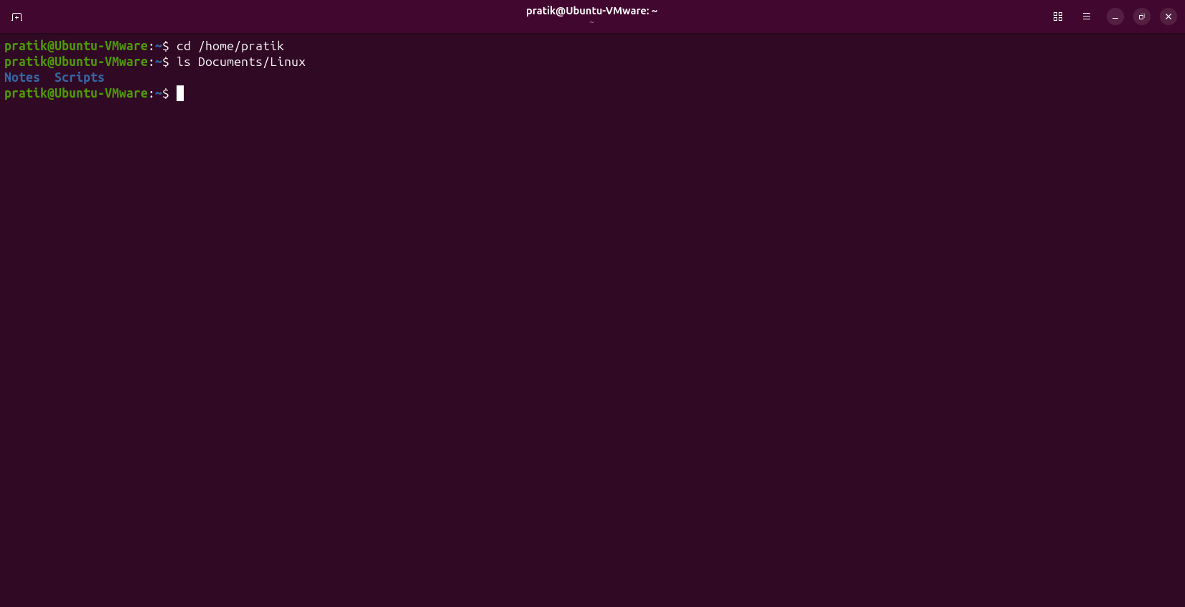

Question
Q11.
Display the contents of employees.txt located in your current directory.

Command
cat employees.txt

Output
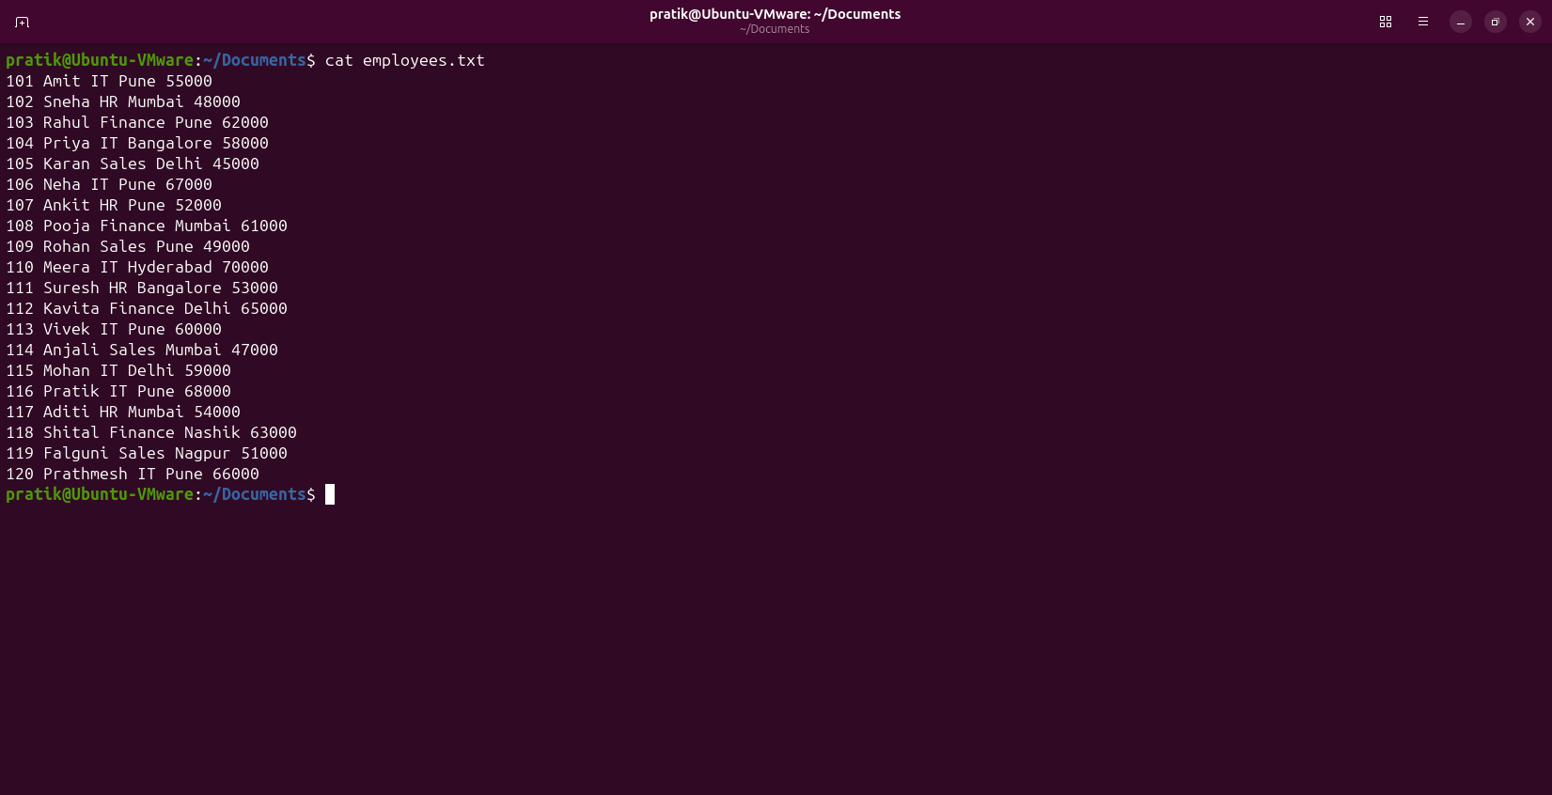

Question
Q12.
Without changing directories, display:
/home/student/Documents/info.txt

Command
cat /home/student/Documents/info.txt

Output
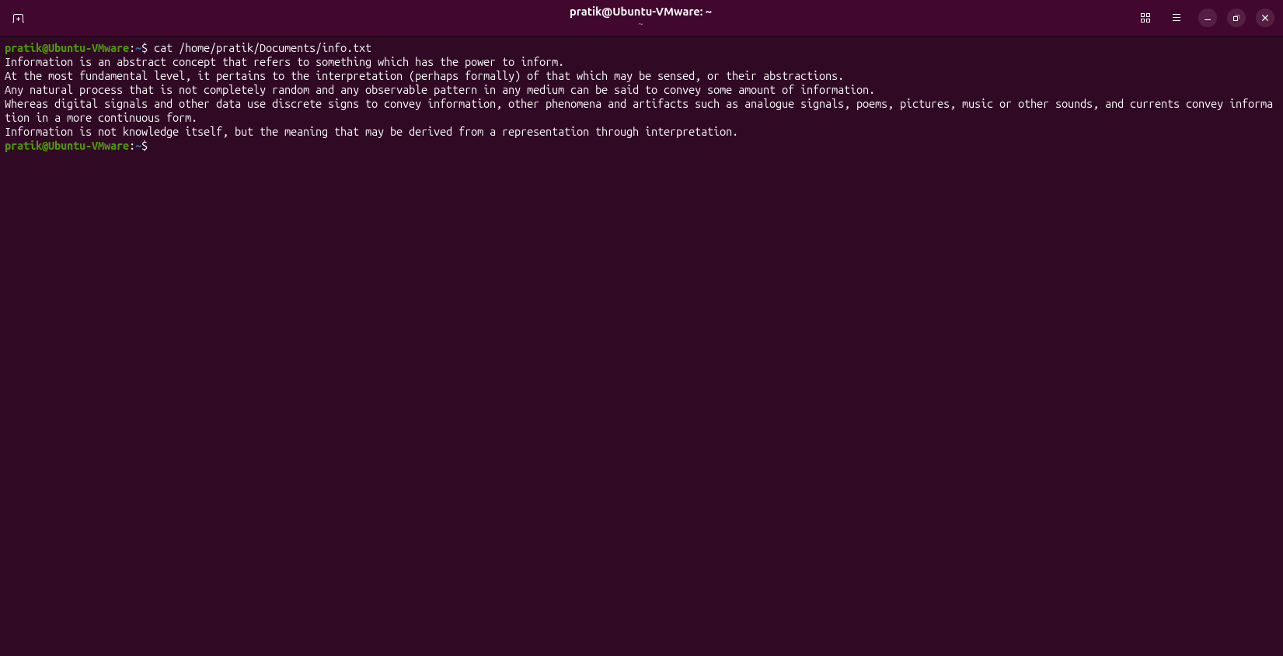

Question
Q13.
Display the contents of two files:
file1.txt
file2.txt
using a single command.

Command
cat file1.txt file2.txt

Output
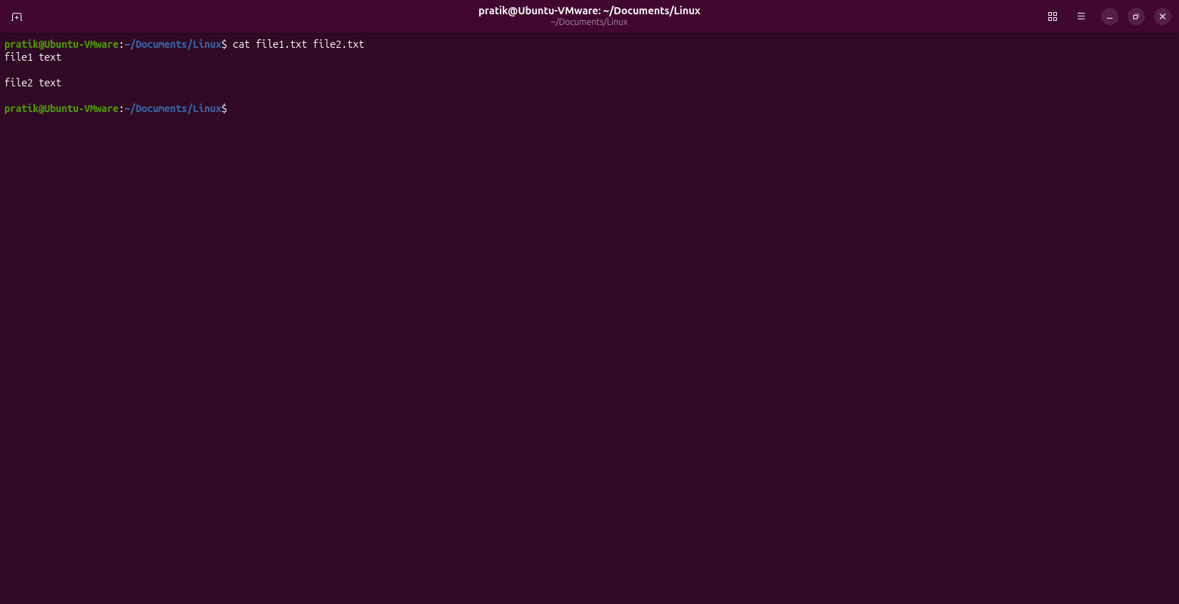

Question
Q14.
Create a file named linux.txt using cat and enter three lines of text.

Command
cat > linux.txt

Output
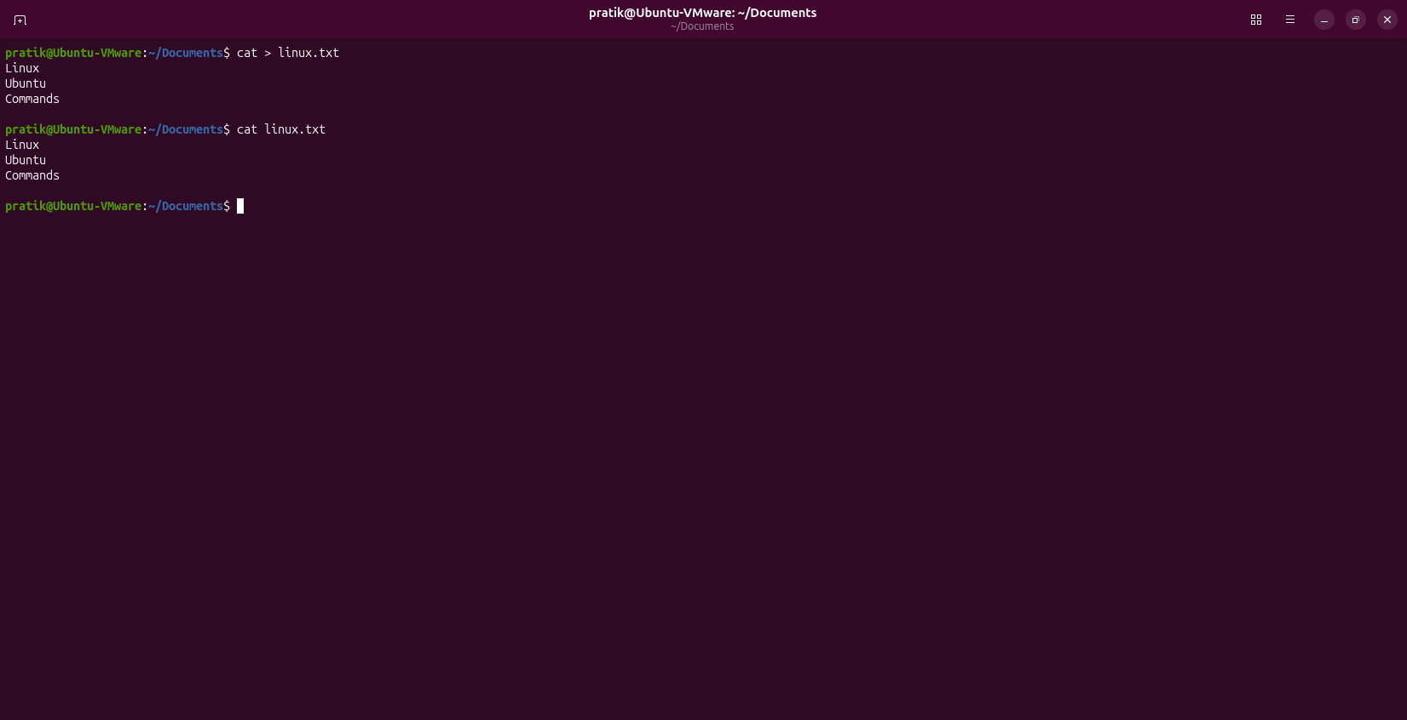

Question
Q15.
Append the text Linux Administration to the end of linux.txt using cat.

Command
cat >> linux.txt

Output
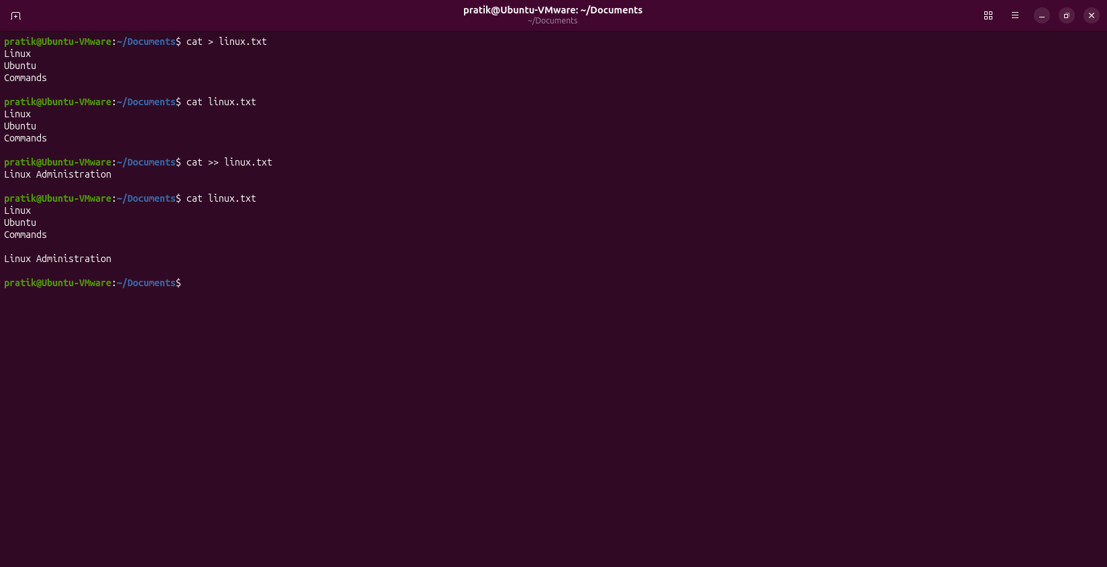

Question
Q16.
Display all employees belonging to the IT department.

Command
grep 'IT' employees.txt

Output
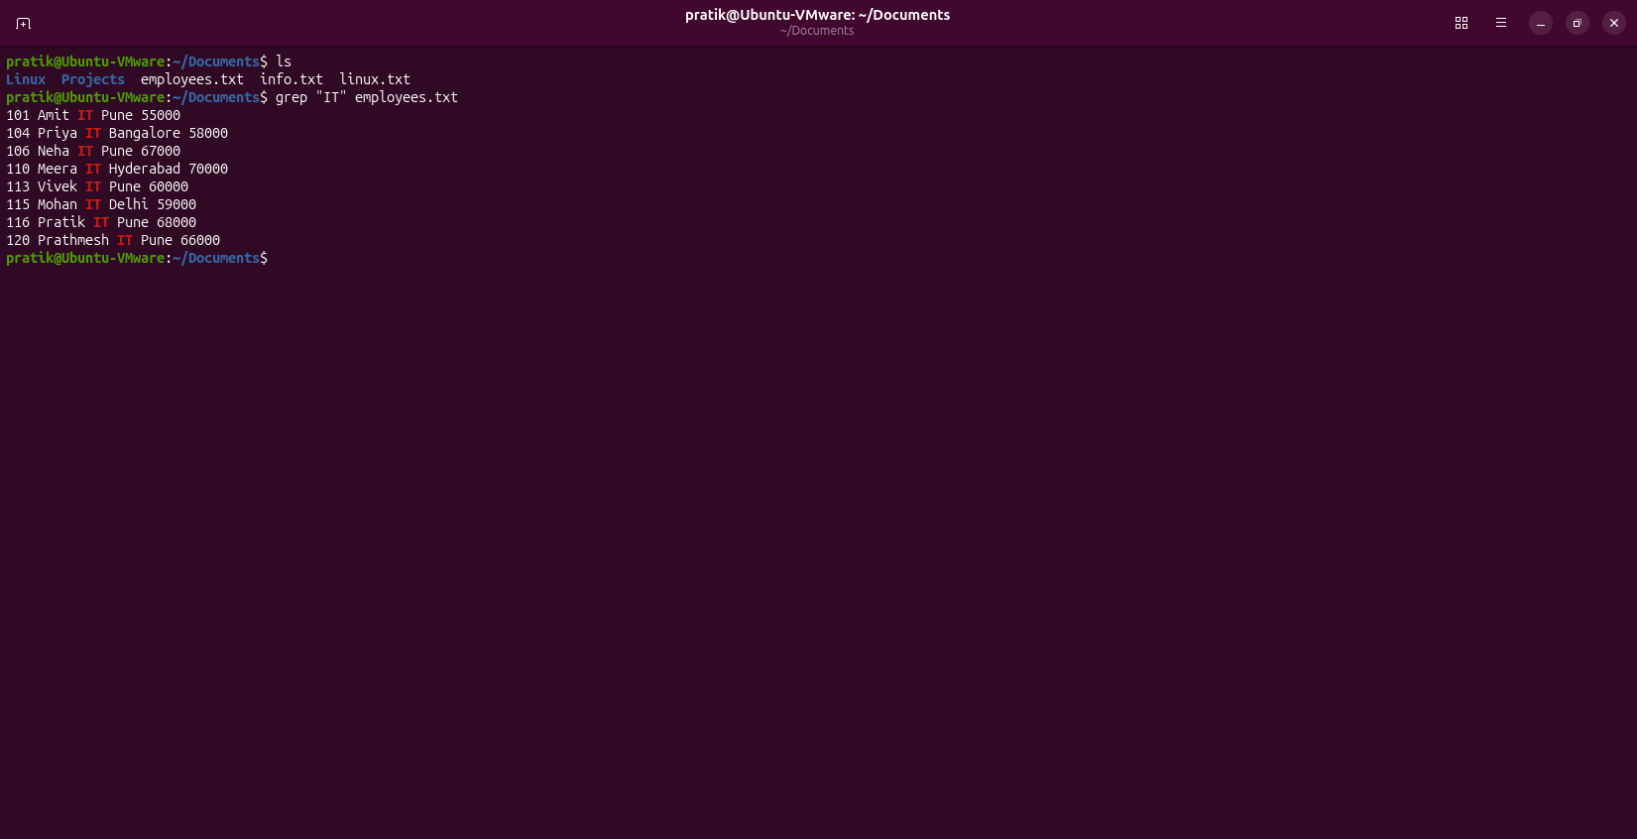

Question
Q17.
Display line numbers along with all matching lines containing Pune.

Command
grep -n 'Pune' employees.txt

Output
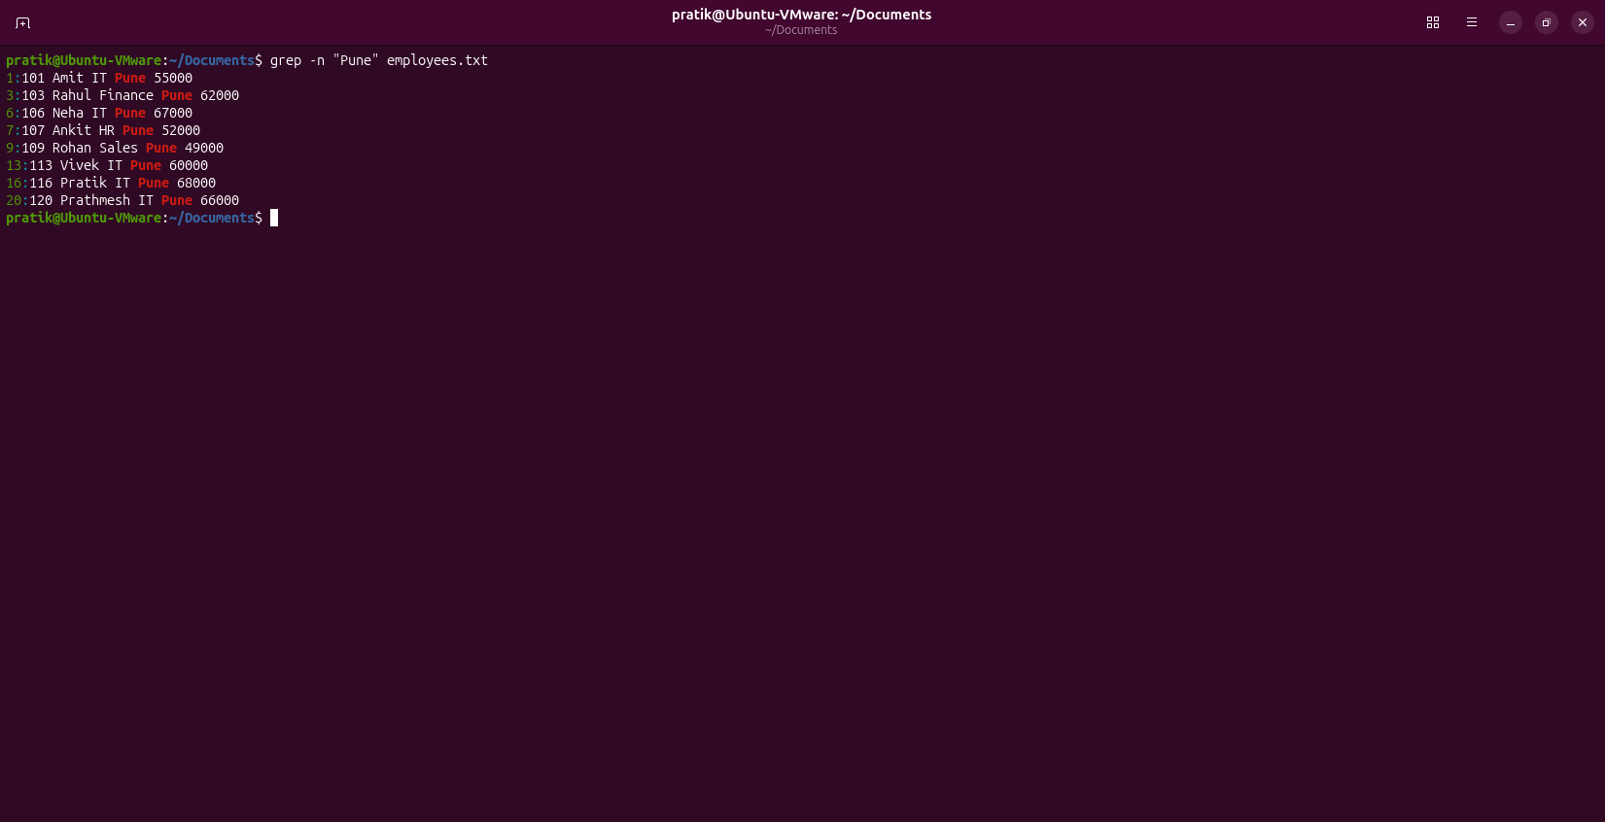

Question
Q18.
Display every line except those containing HR.

Command
grep -v 'HR' employees.txt

Output
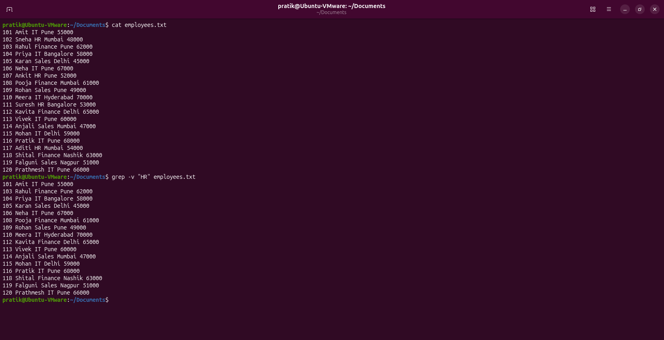

Question
Q19.
Count how many lines contain the word Finance.

Command
grep -c 'Finance' employees.txt

Output
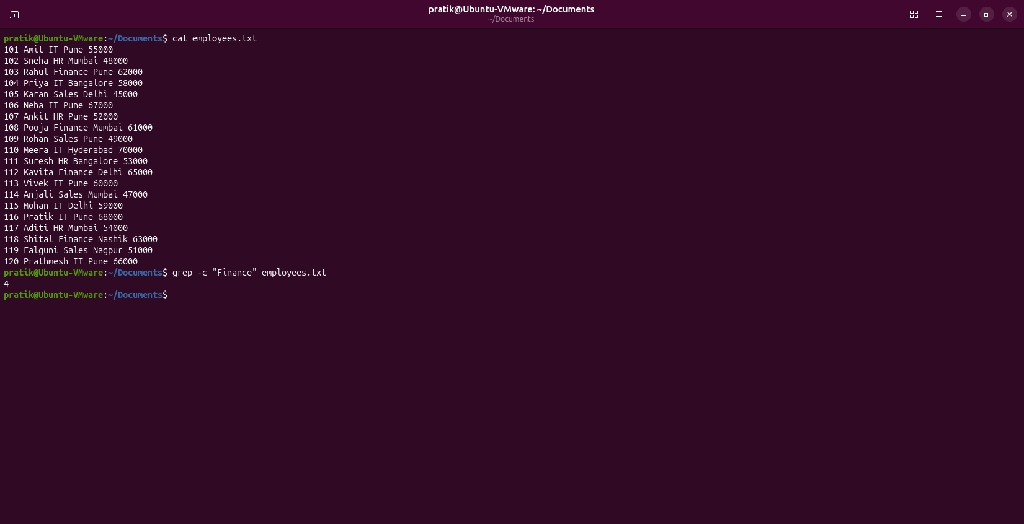

Question
Q20.
Search for the word linux without considering uppercase or lowercase letters.

Command
grep -i 'linux' linux.txt

Output
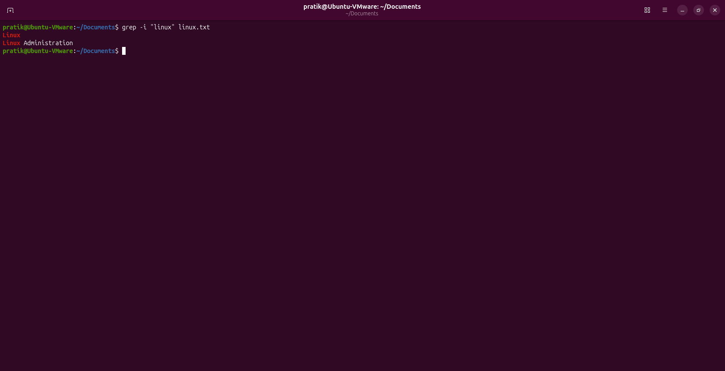

Question
Q21.
Find a file named notes.txt in your home directory.

Command
find ~ -name notes.txt

Output
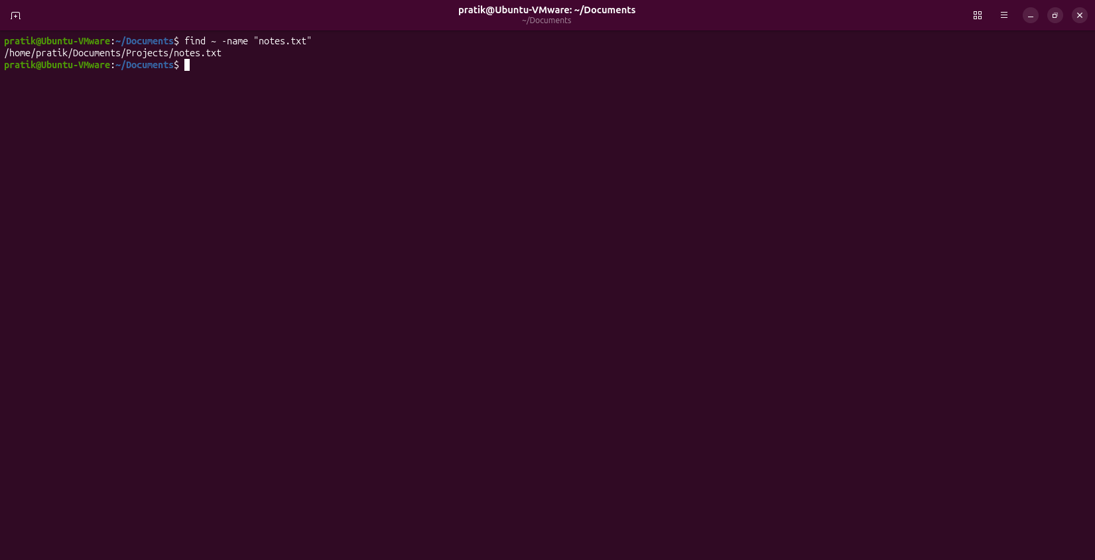

Question
Q22.
Find every directory named Projects.

Command
find ~ -type d -name Projects

Output
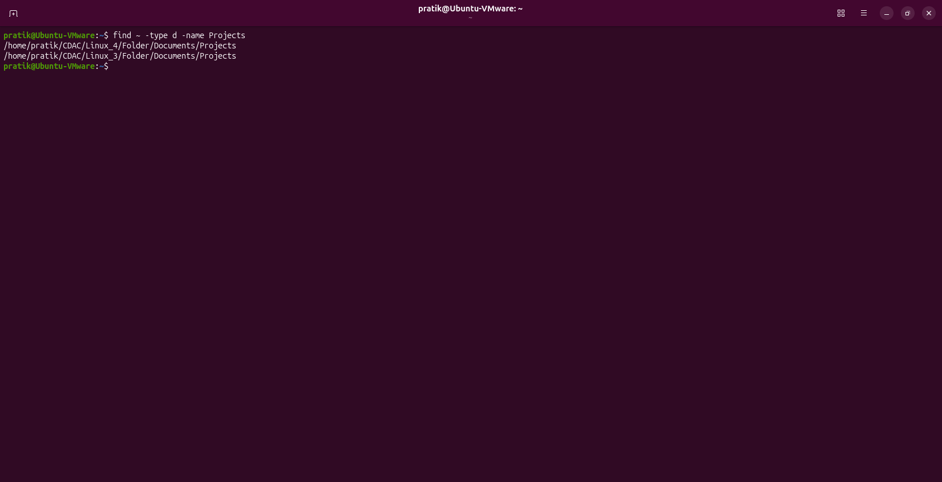

Question
Q23.
Find all files having the .txt extension inside the current directory and its subdirectories.

Command
find . -name '*.txt'

Output
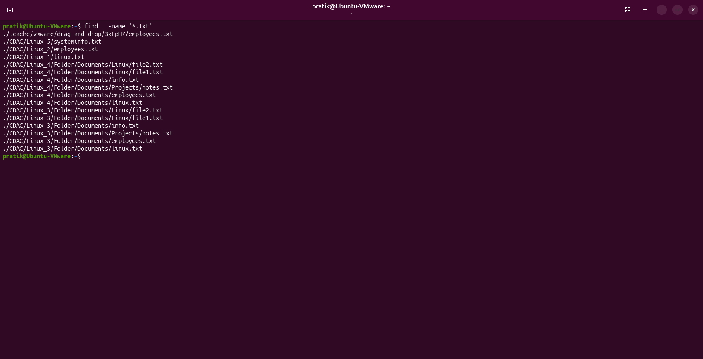

Question
Q24.
Find a file named config.conf starting from the root directory.
(Assume sufficient permissions.)

Command
sudo find / -name “config.conf” 2>/dev/null

Output
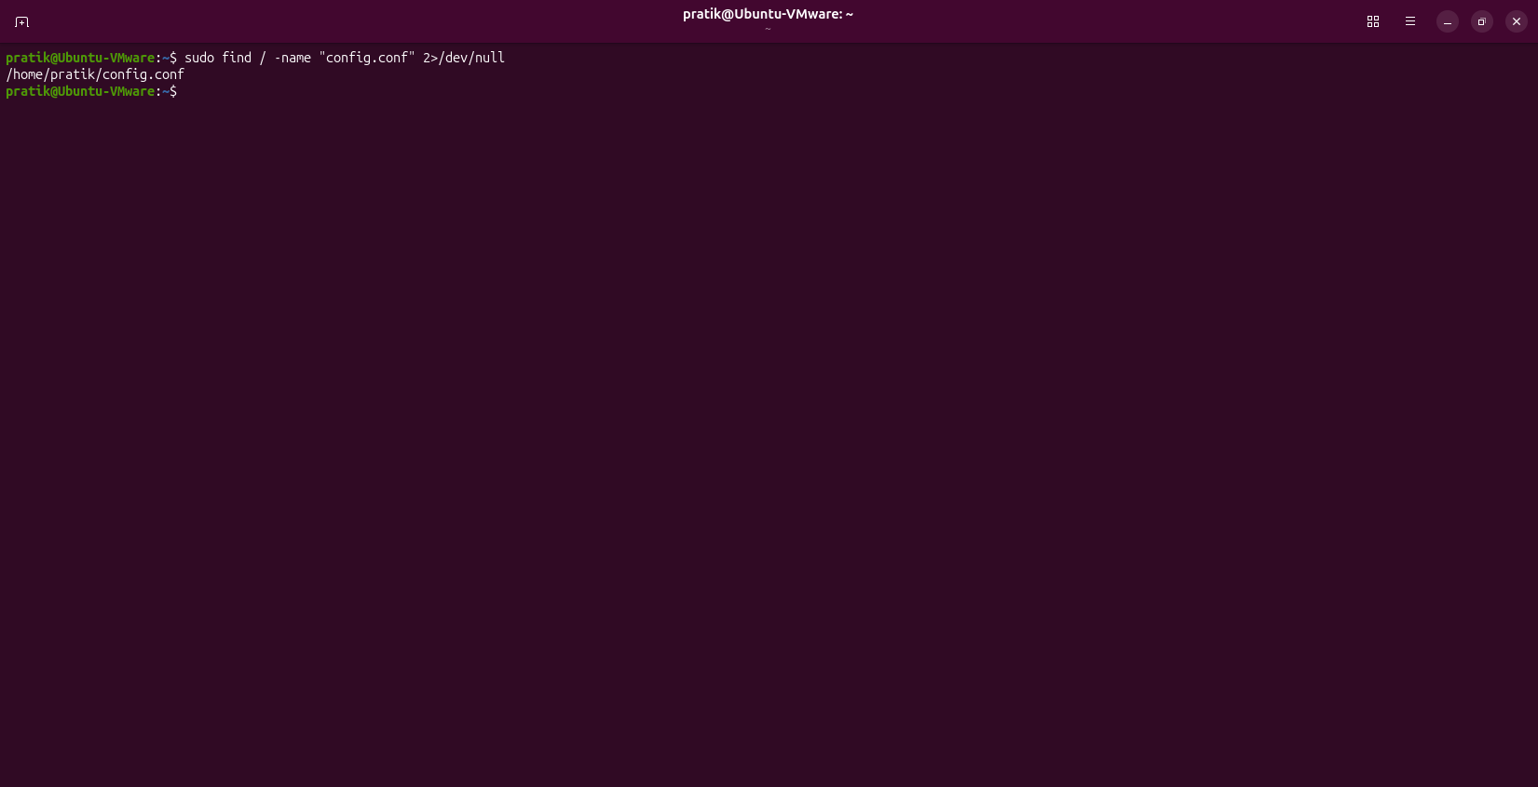

Question
Q25.
Find every file whose name starts with emp.

Command
find . -name 'emp*'

Output
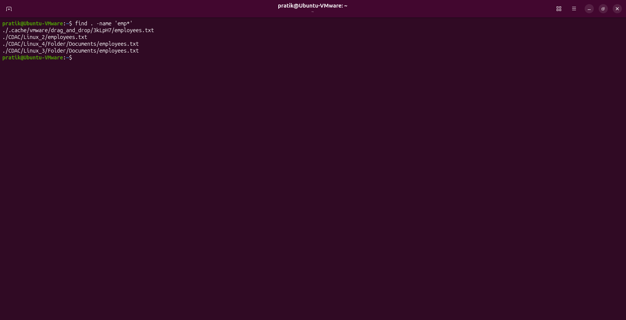

Question
Q26.
Display only the number of lines in employees.txt.

Command
wc -l employees.txt

Output
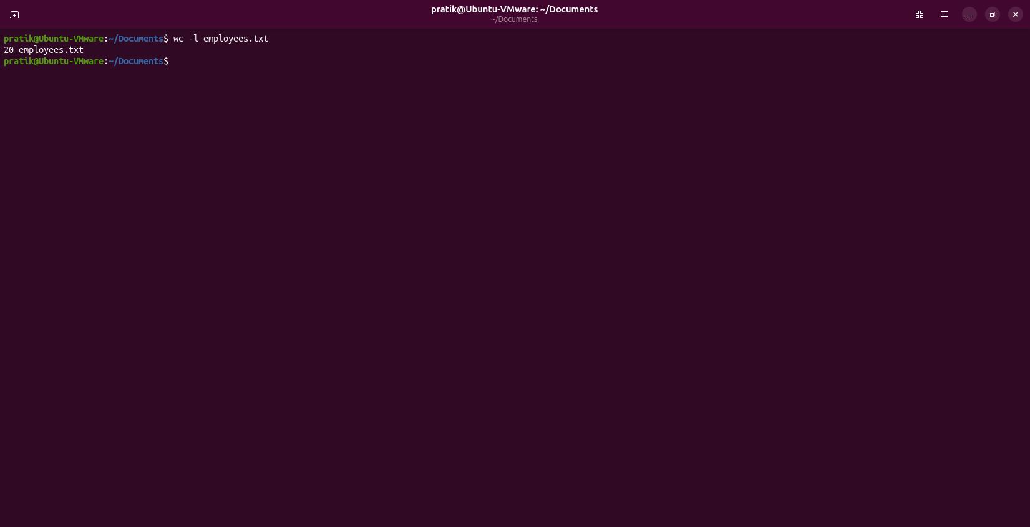

Question
Q27.
Display only the number of words in employees.txt.

Command
wc -w employees.txt

Output
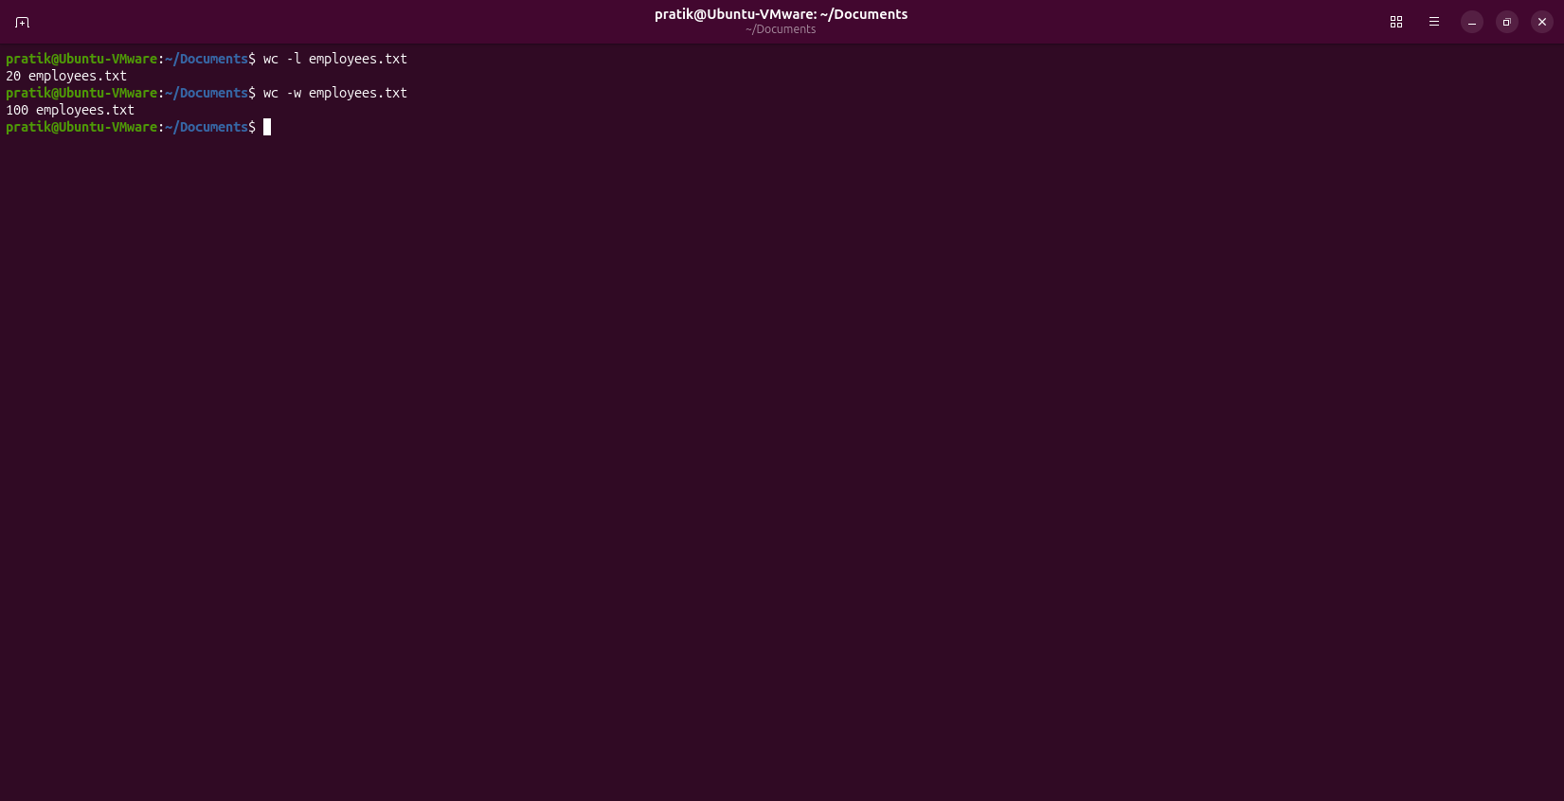

Question
Q28.
Display the number of lines, words, and characters of employees.txt.

Command
wc employees.txt

Output
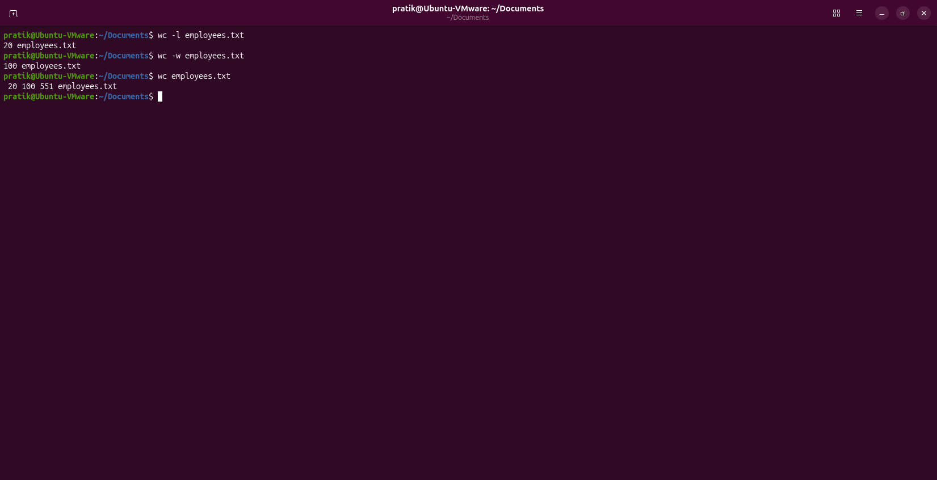

Question
Q29.
Display the contents of employees.txt with line numbers.
Do not use cat -n.

Command
nl employees.txt

Output
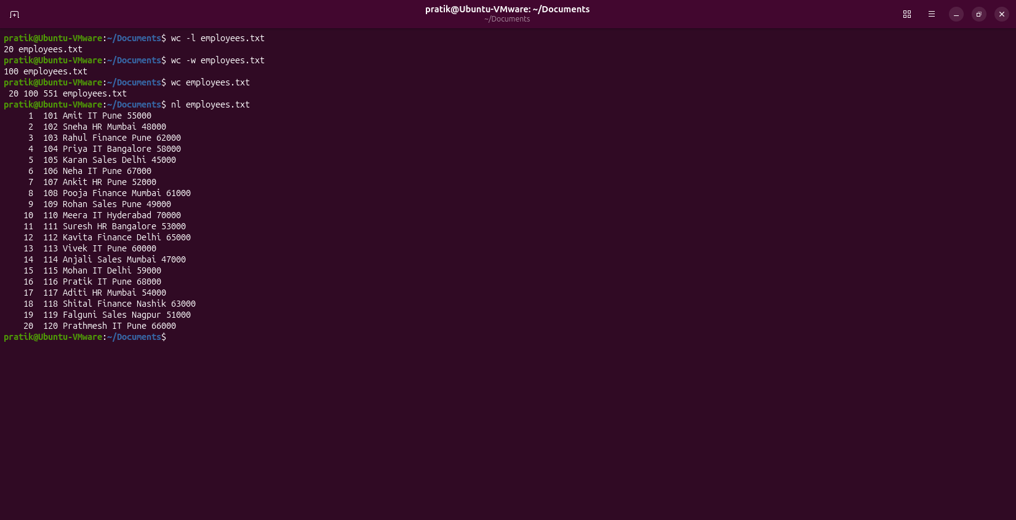

Question
Q30.
Display all environment variables and then find only the variable related to your home directory.

Command
env

Output
